

Project: **SmartHome+**

**Software requirements specifications**

Contents

1. Introduction 2

2. Positioning 2

2.1. Problem Statement 2

3. Stakeholder Descriptions 4

3.1. Stakeholder Summary 4

3.2. User Environment 7

4. Product Overview 7

4.1. Product Perspective 7

4.2. Assumptions and Dependencies 9

4.4. Alternatives and Competition 11

5. Other Product Requirements 11

5.1 Application Standards 11

5.2 Hardware Requirements 11

5.3 Software Requirements 11

5.4 Platform Requirements 12

5.5 Performance Requirements 12

5.6 Environmental Requirements 12

5.7 Features Quality Ranges 13

5.9 External Constraints 13

5.10 Documentation Requirements 14

5.11 Other constraints and dependencies 14

6. Glossary 15

7. Use cases 16

Accessibility 16

Id: UC- 1 16

Environmental Consideration 17

Id: UC-2 18

Energy Efficiency 19

Id: UC- 3 19

Security 21

Id: UC- 4 21

Media and Entertainment 23

Id: UC- 5 24

Automation 25

Id: UC- 6 25

# Introduction

In 2020, with the advancement in peer to peer device communication, coordination and thus automation of tasks has been made much easier. The main goal of the smart-home system is to provide home users with a system to automate everyday home activities, minimize energy consumption, and provide home security, and emergency warnings when need be. With this system we also intend to provide immersive entertainment experience, a better environmental impact and overall ease of use.

# Positioning

### Problem Statement

|  |  |
| --- | --- |
| The problem of | Manual completion of tasks while providing a substandard user experience and inefficient energy consumption. |
| Affects | Owners of the house, their children and their pets |
| The impact of which is | Time and effort wasted on completing activities manually, inefficiency in task completion contributing to overall resource wastage, substandard home security, strenuous use of devices and unpleasant user experience |
| A successful solution would be | Automating tasks resulting in better utilization of time and resources, maximizing home security all the while providing an improved user experience |

* 1. **Product Position Statement**

|  |  |
| --- | --- |
| For | Home Owners |
| Who | want high-tech functionality and luxury |
| The SmartHome+ System | is a centralized device, appliance and system administrator which connects into a common network |
| That | can be independently and remotely controlled while also making customer’s life easier and more enjoyable. |
| Unlike | other smart home systems that can be cumbersome to use and provide much less functionalities |
| Our product | sets itself apart from others by taking a more holistic approach towards resource utilization and thus considers its impact on its customers and the planet. |

# Stakeholder Descriptions

### Stakeholder Summary

|  |  |  |
| --- | --- | --- |
| Name | Description | Responsibilities |
| End Users (Home Owners, Children and Pets) | These are the stakeholders that are primary users of the services provided by our system | * These will be the benefactors who purchase and use the services provided by our platform * They’ll help maintainers create separate profiles for different members in the family thus providing different privileges. e.g.- children would not be able to alter temperature controls of the house. * Home Owners will help regulate settings for various dependents like pets who cannot configure appliances for themselves. For example - set timer for feeding, litter cleaning etc. |
| Platform Providers | Stakeholders that develop processes, resources, frameworks and help solve integration problems and promote easy automation evaluation, functionality, and support. | * System application providers   allow communication between  devices by technologies like  Bluetooth, nfc or more typically  by LAN microchips (which are  developed by a third party).  These provide communication  architecture between devices  which could be of different  brands thus having a common  communication method is  necessary. |
| Regulators | They are stakeholders that ensure a standard of operation is maintained between different devices present in the system. | * The regulators are outer entities overseeing business services or specific industry sectors. This can include certification and accreditation bodies belonging to quality, security, and protection. * An instance of this could be a privacy regulator that develops laws for protection of personally identifiable information from inappropriate exploitation. Presumably, this entity may affect the entire spectrum of industry stakeholders. |
| Network providers | They are the stakeholders that connect the householders and thereby different devices on our platform to the Internet. For instance - Verizon. | * The Network providers supply and handle the   network infrastructure like core network, radio access network, and interconnectivity, network to service providers  Their job is to provide reliable connection between devices for seamless communication in order to guarantee tasks are completed reliably. |
| Device Manufacturers | The manufacturers of appliances, including smart product suppliers such as manufacturers of smart home devices and entertainment devices. | * Householders can buy equipment directly from manufacturers but often through retailers or service providers. * For example - manufacturing companies like Honeywell, Samsung, and LG. |
| Service providers | These stakeholders ensure that necessary resources are constantly provided to the actual location of the home. | * The application service providers and utility companies that provide the end users with hardware equipment to support or enable various smart connected home services. Three examples of service providers are AT&T, verizon * The application service providers and utilities that provide hardware equipment to end users to support or allow various smart home connected services. AT&T, verisure, and Leak Protection are three examples of service providers. * These services might include but not limited to, internet connection, water supply, electricity etc. |
| Hackers | A group of users who tries to access unauthorized information of the system. | * These are negative stakeholders that could try to access data from our internal network system. This information is sensitive and should not be compromised to ensure security and privacy to users. |
| Thieves/Trespassers | A group of users that try to bypass home security in order to potentially harm the peace and wellbeing of the owners. | * These are also negative stakeholders that would be affected by our system. Motion sensors and alarm systems would be used to identify unexpected movement in the property's vicinity and the user will be informed via notifications on their remote device. |

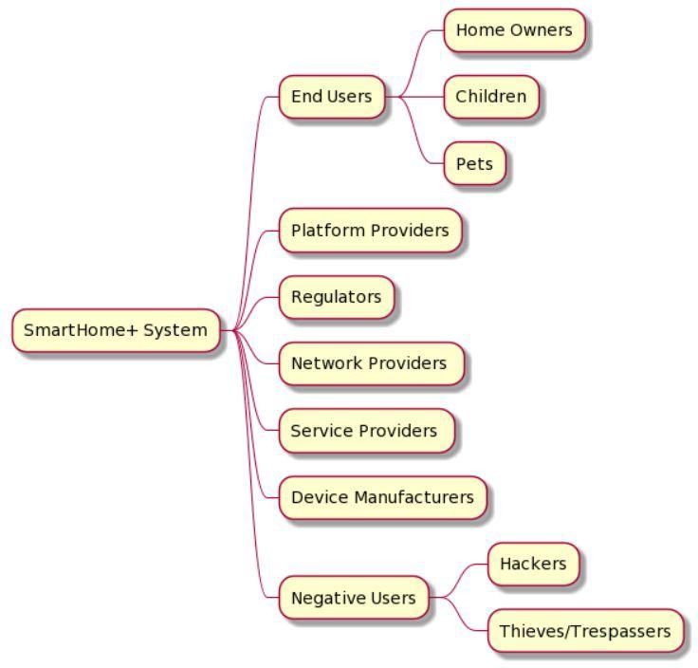

Figure 1: Mind-Map of Stakeholders in SmartHome+ System

### User Environment

* + - Smart home technology which may also be termed as home automation allows the user to remotely monitor, control or access and provide services that respond to the perceived needs of the clients.
    - The smart home can be controlled using an application on your smart device, or from the physical device in your home, allowing both remote and local access.
    - System features can be accessed/controlled through the application by entering access code, biometric or two factor authentication.
    - The Internet is needed to access the smart home via application and all the devices are connected to the internet.
    - SmartHome can be integrated with the existing Amazon echo family, Samsung SmartThings Wifi Smart Plug, Wyze Cam Pan, August Smart Lock Pro + Connect and can be improvised.
    - SmartHome is an easy to use device which comes with a user manual. But few users may need the demo of the system before they start using it.
    - We can extend the smart home system which was designed especially for the home to other areas.

# Product Overview

### Product Perspective

Our product is part of a larger system. The system with the help of peer to peer connected devices shares information and makes routined decisions based on it. For example-

* + - Connection with emergency services-
      * When motion sensors directed towards the gate detect a movement with an unrecognized device or an RFID tag, the sensors inform the system which in turn sends over a notification to the end user. The user in that case could choose whether to dismiss the notification or be aware of trespassers.
      * If the sensors detect a breaking and entering situation however, the system in addition to sending the user a notification also alerts the local police department for possible emergencies based on the situation. In case of a fire the system could also notify the fire department.
      * The interface used in these situations would not be like 911 type notifications that automatically sends over the location and the situation type to the concerned department.
      * With the help of location tracking these departments would also get the location of users so that priority could be set over that area accordingly. Suppose in case of fire the system detects an active remote in the backyard (i.e a user in the backyard) it sends that information to the fire department so they could focus their efforts in that part of the property.
    - Security and monitoring subsystem-
      * This subsystem interacts with the SmartHome+ to give high accessibility and security with features such as Access code entry, Biometric pass and two-factor authentication. They are used based on the situation and users’ preferences.
      * Surveillance cameras are in place and they can be accessed from the system.
      * In order to ensure that a task has been completed reliably by the system the
      * users could receive a notification about the status of the task.
    - User giving voice commands -
      * With a microphone available in remote, users who cannot physically interact/type with the devices can use a provided assistant to give voice commands that the system would process and follow.
      * This cannot be done in a closed system as the voice needs to be translated to machine understandable instructions using natural language processing systems not unlike what’s used in other voice assistants like Alexa, Siri etc.
    - Light adjustable entertainment center-
      * This part of the system would be self-contained as it only needs to identify the edges of the television set and change the colors of surrounding lights based on the corresponding color it detects.
    - Energy resources -
      * All devices such as Lights, Power, electronic appliances are connected to the main system.
      * These devices can be set to automatically turn on and off on certain events.
      * SmartHome+ provides an option controlling these resources.
    - Automatic Pet Care products-
      * This part of the system ensures that the pets in the house are always attended and its status and activities are tracked from the SmartHome+ system.
      * GPS tracking bands would enable users to track the pet via the system and also allow to set the frequency for the automatic pet feeder and cleaning schedule for the self cleaning box.
      * an interactive play area is a media device that plays sounds, provides interactive content for the pets and this could be done and monitored from the system.

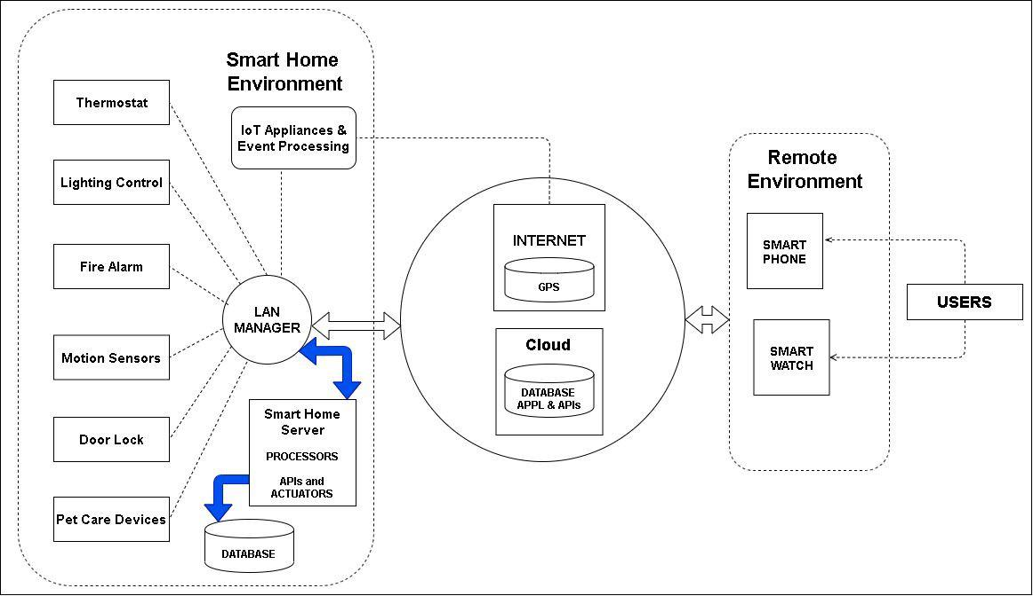

Figure 2: Block Diagram for SmartHome+ System

### Assumptions and Dependencies

|  |  |
| --- | --- |
| Assumptions | Dependencies |
| Users of SmartHome+ system have basic knowledge of using Smart Apps | Mode of communication and usage of the system |
| Users having Proficiency in language | System is available in English |
| Strong internet Connectivity | Fast Internet connection and network availability |
| Power supply and backup | Having a consistent power supply always (24/7) |
| Access to location and other user details | Permissions for accessing location and user identification details and sharing them with emergency services |
| Smart devices are connected with each other easily. | System supports cross platform apps to be connected and communicative together. |

* 1. **Needs and Features**

|  |  |  |  |
| --- | --- | --- | --- |
| Need | Priority | Features | Planned Release |
| Easy to use (Accessibility) | High | * user can control actions using voice commands * tasks are mostly automated so user does not have to manually check on things | -v1.0 |
|  |  |  |
| Secure (Security) | High | * inter device communication is end to end encrypted so that hackers cannot access information from network * alarm systems and motion detectors are practically connected to emergency services and the user’s device respectively | -v1.1 |
| Aesthetic value (Media and Entertainment) | Normal | * Entertainment center with background lighting adds a more immersive experience while watching television. * motion sensors and cameras are minimalist in looks so they don’t hamper the architectural aesthetic of the building | -v1.3 |
| Efficiency of tasks (Energy efficiency / management) | Low | * since tasks are not to be done manually, user can be sure that the tasks assigned to the system would be completed reliably * In case something cannot be completed the user will be notified as well thus negating stress | -v1.2 |
| Resource management | Normal | * Once the user has been using the system for some time, the system will learn patterns and thus allocate resources based on previous usage or the user can have an option to opt for fully manual mode in the system and prevent any more automated modifications in that area.   For example- if a particular room like an attic is not visited for some time it won’t be heated automatically thus saving heat. | -v1.2 |
| Environmental consideration | Normal | * The system is set to periodically monitor the quality of air and water. * Quality of water and air can be set by users’ values and if the value of an element is more or less than what the user set, the system has to be alert. | -v1.2 |

### Alternatives and Competition

* + - Samsung SmartThings Hub
      * Strengths:
        + Wireless ethernet (Wi-Fi) connectivity.
        + Appealing product architecture.
      * Weaknesses:
        + The second-gen SmartThings Hub has no migration route.
        + SmartThings still don't help certain big product families (e.g. Nest and August).
        + Backup battery deleted.
    - Minut Smart Home Alarm
      * Strengths:
        + Powerful Infrared Motion Sensor.
        + In-depth look at the environmental conditions in your home.
      * Weaknesses:
        + Can't monitor smart home appliances like lights and smart locks.
        + Provides effective security for only one room as it has all in one architecture.
        + Pets can easily set off the alarm due to its super sensitive functionality.
    - Wink Hub 2
      * Strengths:
        + Supports all smart home protocols which are popular.
        + No ethernet cable required.
      * Weaknesses:
        + No built-in battery back-up.

# Other Product Requirements

## Application Standards

* + - Our system would comply with various certifications which will be provided by regulators.
    - For internet communication- TCP/IP
    - For location detection- GPS protocol
    - Platform dependency for Server- Linux , Mac, Window
    - For database- SQL

## Hardware Requirements

* + - LAN Manager acts as a central communicator that links all of the different devices into one smart home.
    - The LAN Manager should provide an internet connectivity to allow you to track and control your devices while you're away.
    - LAN Manager has communication radios which communicate with your various devices.
    - Separate database to store data like settings information and status of various devices.
    - Wide ranges of power inputs.
    - The price should be reasonable.

## Software Requirements

* + - One issue with having a variety of smart devices without integrating them under one

platform is that all the devices cannot be controlled using one single application.

* + - One application will control the lights, one will control the thermostat, and a third application will allow you to play music.
    - Software hubs in the form of Smart Home Server solve this by bringing all these controls into one program interface. They put everything in one place by simply downloading the app on your phone, and then linking it to the numerous other applications that control devices on your device.
    - Once this is done then, instead of jumping around, users can run all those devices from one single app. Software hubs are free to use and require little commitment.

## Platform Requirements

* + - Usability- User interfaces should be easy to navigate and nice to look at.
    - Extensibility- System should support expansion so that it offers range extenders for a very large home.
    - Compatibility- System should support compatible device offerings.
    - Security- The System should support security as issues are over-hyped and hackers cannot inject commands from outside into the internal working of the system since hackers don’t roam around trying to take over people’s devices.
    - Usability- System should support voice control.
    - Supportability- System should provide multi-user support.
    - Compatibility- System should support cross platform.

## Performance Requirements

* + - Availability- System should be available 24/7.
    - Modifiability- System server supports multiple users, updates information costly effectively.
    - Performability (Capacity)-System supports 100 devices including sensors.
    - Performability (Time Behavior)- The response of the system to handle data from the sensor is within 0.1 sec.

## Environmental Requirements

* + - Fire monitoring:

1. Heat and smoke detectors can help protect the family and the belongings.
2. Heat and smoke detectors use advanced technology to alert the monitoring centre when we’re not there.
   * + Carbon monoxide (CO) monitoring:

1. Carbon monoxide detectors alert the monitoring centres so we can contact emergency responders when CO levels are high and dangerous.

* + - Temperature fluctuation protection:

1. If abnormal temperature fluctuations happen, it helps prevent damage caused.
2. Detecting fluctuations in temperature helps prevent frozen pipes from bursting which is often caused by a broken central heating system.
   * + Flood protection:
3. Flood detectors alert the monitoring centres of rising water levels in a home.
4. Detecting water helps prevent flooding and reducing the damage it causes.

## Features Quality Ranges

|  |  |
| --- | --- |
| **Features** | **Quality Ranges** |
| Performability | High |
| Availability | High |
| Usability | High |
| Connectivity between devices | High |
| Reliability | High |
| Fault Tolerance | High |
| Robustness | Medium |
| Recoverability | Medium |
| Maintainability | Medium |
| Portability/ Compatibility | Low |

* 1. **Design Constraints**
     + Portability- System should be designed with the extensibility to add new devices.
     + Time Behaviour- The database system needs to be implemented as a real-time system with quick response.
     + Cost Effectiveness- Devices shall be within cost budget.
     + Operability- Devices shall be easily operated.

## External Constraints

* + - Resource Utilization- Energy consumption challenges can largely be addressed by adoption of smart-home and the designed systems should use very less energy.
    - Adaptability- SmartHome+ have to evolve with the needs and prerequisites of their users, adapting to new schedules and habits.
    - Sustainability- Policy is required or recommended ways of working under government regulations.

## Documentation Requirements

* + - Install ability- SmartHome+ needs installation and setup to connect with the smart devices at home.
    - Usability- There would be a user manual to help users to reset the settings, create user profiles, reset security controls and a guide on using the controls of the SmartHome+ system.
    - Usability- Since this system is used by many first time users, there will be a video tutorial on the tasks the system can perform.

## Other constraints and dependencies

|  |  |
| --- | --- |
| **Design/External Constraints** | **Dependencies** |
| Time | Total time taken to deliver the product to customer |
| Portability | System should support multiple platforms. |
| Affordability/ Cost Effectiveness | System should provide enormous features within the customer price range. |
| Security | Authenticity, Integrity and Confidentiality to authorized users. |
| Capacity | Number of devices that can access software products concurrently. |

|  |  |
| --- | --- |
| Applicable Standards | Low |
| Hardware Requirements | High |
| Software Requirements | High |
| Platform Requirements | High |
| Performance Requirements | High |
| Environmental Requirements | Medium |
| Design constraints, external constraints or other dependencies | Low |
| Documentation Requirements | Medium |

* 1. **Priority of other product requirement**

******************************************************************************************

************* Need to find Defects before Glossary Part ****************************

*******************************************************************************************

# Glossary

1. 911: is an emergency telephone number for the North American Numbering Plan (NANP)
2. Alexa: It is a voice-controlled Amazon assistant that turns words into actions.
3. GPS: Global Positioning System, is a global navigation satellite system that provides location, velocity and time synchronization.
4. LAN Manager (LM): It includes client computer and server software from that allows users to link personal devices together on a single network
5. Location tracking: It refers to technologies that physically locate and electronically record and track the movement of people or objects. Location tracking technology is in use every day with GPS navigation.
6. Minut Smart Home Alarm: Minut’s infrared-detecting security system offers best-in-class motion detection.
7. Remote Devices: Mobile devices or Smart Watches
8. RFID(radio frequency identification): It is a form of wireless communication that incorporates the use of electromagnetic or electrostatic coupling in the radio frequency portion of the electromagnetic spectrum to uniquely identify an object, animal or person. Use cases for RFID technology include healthcare, manufacturing, inventory management, shipping, retail sales and home use.
9. Samsung SmartThings Hub: Connect wirelessly with a wide range of smart devices and make them work together.
10. Siri: Siri is a virtual assistant that is part of Apple Inc.'s iOS, iPadOS, watchOS, macOS, and tvOS operating systems. The assistant uses voice queries and a natural-language user interface to answer questions, make recommendations, and perform actions by delegating requests to a set of Internet services.
11. Smart device: is an electronic device, generally connected to other devices or networks via

different wireless protocols such as Bluetooth, Zigbee, NFC, Wi-Fi,

1. Voice assistant: Voice assistant is a software agent that can perform tasks or services for an individual based on commands or questions.
2. Wink Hub 2: The Wink Hub 2 is a stellar smart home system that capably organizes and coordinates your various smart devices.
3. Wireless Ethernet: This is a standard for wireless networking within an organization or a home. It

is also known as a WiFi network.

# Use cases

## Accessibility

1. **Actor-Goal List**

|  |  |
| --- | --- |
| **Actor** | **Goal** |
| SmartHome Owners | * give voice commands to the SmartHome System * give commands to the SmartHome System via Smart devices remotely * Set the SmartHome System actions manually |

1. **Use Case Model**

##### Package: Main

### Id: UC- 1

**Use Case**: Configuring the Accessibility Services

**Description**: The SmartHome receives user commands by their voice and by their smart devices such as SmartPhones, Tablets, Smart watches and so on. In that case users are able to control their home every time they want even remotely. For example if a user is out and wants to have a coffee when he arrives home, he can easily access his smart coffee maker to set it into making his coffee in the desired time. Also there is a manually option for users to change accessibility functions. For instance parents can lock the access of the stove for their kids.

**Level:** Summary

##### Primary Actor

SmartHome Owners

**Supporting Actors** SmartHome System SmartHome application

##### Stakeholders and Interests

SmartHome Owners want to have access to every smart tool and can give them any command they want by their voice or through their smart devices. They want to have a quick and easy application for their SmartHome which can be easily learned and used.

##### Pre-Conditions

* 1. SmartHome tools have to be connected to the System accurately.
  2. SmartHome’s application has to work well and have access to every SmartHome tool.

##### Post Conditions

Success end condition

1. Owners can give commands to the system.
2. System can respond in an accurate way to users' commands.

Failure end condition:

1. System responds to users’ commands in a different way.
2. System doesn’t respond to any command.
3. System has some systematic errors which are not visible for users.

Minimal Guarantee

1. System is able to show the exact error to users while it’s not working.

***Main Success Scenario***

1. System responds to users’ commands.
2. System notifies users if any error has occurred.
3. System allows access from any mobile device.
4. System allows parents to restrict their kids' access.
5. Users can set operations manually.

#### Extensions

* 1. There are 3 kinds of error can happen:
     1. Systematic error which is not visible for users.
     2. Functionality errors
     3. Missing Command Errors

## Environmental Consideration

1. **Actor-Goal List**

|  |  |
| --- | --- |
| **Actor** | **Goal** |
| SmartHome System | * Monitoring air quality * Monitoring water quality |

1. **Use Case Model**

##### Package: Main

### Id: UC-2

**Use Case:** Monitor Quality of Air & water

**Description**: The SmartHome system has some sensors to detect air/ water quality and in cases of observing any unordinary element in the atmosphere or consuming water, it will alert users. Also the amount of elements in the air and water can be checked by the user and if it is below or above the values that the user set, the system will notify the user.

**Level:** Subfunction

##### Primary Actor

SmartHome System

##### Supporting Actors

SmartHome Owners

##### Stakeholders and Interests

SmartHome Owners want to be notified by the quality of the air and water which are consuming.

##### Pre-Conditions

* 1. Sensors, alarms are active.
  2. SmartHome+ system works in the correct manner.
  3. Sensors are able to detect and trigger alarms.

##### Post Conditions

1. SmartHome Owners can check the quality of air and water.

Success end condition

1. SmartHome Owners are notified and updated successfully.

Failure end condition:

* 1. Alarm is unable to trigger alert.
  2. System is not working well and cannot improve the quality.
  3. System works in a different way and causes many damages such as deterioration of the quality of air or water.
  4. System fails to reach out to the owners.

Minimal Guarantee

1. Home Owners are notified of the alert

#### Main Success Scenario

1. The system is set to periodically monitor the quality of air and water.
2. There are sensors that would check the quality and reflect the same in the system
3. Quality of water and air can be set by users’ values and if the value of an element is more or less than what the user set, the system has to notify.
4. System detects any extra element in the air or water and alerts owners.
5. There is an alert sign post on the dashboard so that the user looks into this.
6. Users can keep track of the quality value and perform necessary action to maintain that value.

## Energy Efficiency

* 1. **Actor-Goal List**

|  |  |
| --- | --- |
| **Actor** | **Goal** |
| SmartHome System | * Learns users' habits in using energy. * Receives user locations to set the tools. * Reduces energy costs. |

* 1. Use Case Model
  2. Package: Main

### Id: UC- 3

Use Case: Energy Efficiency Services

**Description:** The SmartHome System learns user daily usage of smart tools like Thermostat, Lights, TV and so on. Based on that the system will provide an optimal program to manage energy consumption of the house. For instance, room sensors can detect the area and if no one is in the room, It will turn off the heating. The system always checks users location and heating will be turned on before the users arrive home. Thus, it will help to reduce the costs and better energy saving. There is a manually mode for users who want to change the setting or give commands to the system. Also if the system faces any error, it will alert owners.

**Level:** Subfunction **Primary Actor** SmartHome System **Supporting Actors** SmartHome Owners

###### Stakeholders and Interests

SmartHome Owners - wants to be notified about their energy usage. They would like to reduce their energy costs.

###### Pre-Conditions

1. Sensors are active.
2. SmartHome+ system works in the correct manner.
3. Sensors able to detect the area and temperature.

###### Post Conditions

Success end condition

* 1. Sensors detect accurately.
  2. System program is efficient and smart.It can consider every element in energy saving such as season, peak hours, the number of people in the room and users habits.

Failure end condition:

1. If sensors don’t work well, it has many cost effects like overusages, destroying home equipment, fire and so on.
2. System has some systematic errors which are not visible for users.

Minimal Guarantee

1. Home Owners were notified of the error in the system before mishap happens.

#### Main Success Scenario

* 1. System works well and provides the optimal program for the energy consumption of the house.
  2. System receives the user locations and commands.
  3. System sets smart tools based on users' habits.
  4. System is able to detect every element of the house.
  5. System triggers the alarms based on sensor data.
  6. System notifies the owner about the alert.

#### Extensions

* + 1. If the owner have dismissed the alert, 2 cases will happen:
       - Alert is dismissed and alarm is stopped.
       - In critical situations alert should be sent again.

## Security

1. **Actor-Goal List**

|  |  |
| --- | --- |
| **Actor** | **Goal** |
| SmartHome System | * Trigger the relevant alarms * Notify the home owners about alerts * Notify authorities about any alerts deemed suspicious by the Owner/User. |

1. **Use Case Model**

##### Package: Main

### Id: UC- 4

**Use Case:** Alert Emergency services

**Description:** The sensors at the SmartHome detect if there is any smoke in the house or if there is any water or gas leakage. There are also sensors to detect if someone tries to trespass the house without the owner's knowledge. In such a case, the sensors would first notify the owner about the alert and unless the owner verifies it to be true, it won't proceed to notify the emergency authorities. However, in case of any calamity, the system directly notifies the authorities also.

**Level:** Subfunction

##### Primary Actor

SmartHome system

##### Supporting Actors

SmartHome Owner Emergency Services

##### Stakeholders and Interests

SmartHome Owners - wants to be notified about any alarms, trespassing or illegal access activities.

Emergency Services - want to be notified quickly about any suspicious movement or emergency situations.

##### Pre-Conditions

* 1. Sensors, alarms and video surveillance in working condition.
  2. SmartHome+ system works in the correct manner.
  3. Sensors able to detect and trigger alarms.
  4. Emergency contact details are stored in the system.

##### Post Conditions

Success end condition

1. Owner is notified and updated successfully.
2. Emergency authorities are successfully alerted.
3. Rescue and recovery operations are successfully carried out.
4. Alert is successfully closed.
5. Owner closes the event in the system.

Failure end condition:

1. Alarm is unable to trigger alert.
2. System is programmed to behave differently.
3. System fails to reach out to the owner.

Minimal Guarantee

1. Home Owners notified of the alert
2. Authorities notified of the alert

***Main Success Scenario***

1. System detects any leakage, fire or trespassing, through sensors
2. System triggers the alarms based on sensor data.
3. System notifies the owner about the alert
4. Based on the type of alert the owner would respond.
5. Owner has live CCTV footage access and based on it, either dismisses the alert or takes it further
6. System contacts the emergency services with the correct alert type.
7. System sends the house details and location to authorities.
8. System sends alarm information to authorities
9. System is able to detect and depict the source of the alert.
10. Rescue authorities are able to carry out recovery operations successfully.

#### Extensions

3a. In case of fire outbreak or any leakage, the authorities are contacted directly.

1. System contacts the emergency services directly.
2. The owner is alerted/notified about the emergency.
3. System updates the owner once the alert has been resolved.

5b. If the owner have dismissed the alert of trespassing due to some reason (alarm was falsely triggered)

1. Alert is dismissed
2. Alarm is cancelled.
3. System logs the event and closes it.

#### Special Requirements

Security

1. User’s data should be safe and only shared with the authorities upon consent from the owner.

Performance

1. The system should be able to notify of any alerts in less than 10 seconds.

User Interface

1. Once there is an emergency alert, the system’s UI should be able to display the source of the alert.
2. The UI should also be able to show the presence of living beings in their respective locations, during emergency situations.

## Media and Entertainment

1. **Actor-Goal List**

|  |  |
| --- | --- |
| **Actor** | **Goal** |
| SmarHome+ System | * Set the color of ambient lights surrounding the TV   set |
| User | * Attain a more immersive experience for the user |

1. **Use Case Model**

##### Package: Main

### Id: UC- 5

Use Case: Background lighting for entertainment center

##### Description

Ambient lights present in our smarthome system help provide a great visual experience while watching television. The lights would be present near the perimeter of the screen hence lighting up the boundaries in various color shades. These shades would be determined automatically by our vision sensors and they’ll use the content being played on the screen as basis.

**Level:** Subfunction

##### Primary Actor

Smarthome system

##### Supporting Actors

* Lights
* Television set
* Mobile device

##### Stakeholders and Interests

* Owners
  + Lights surrounding the TV should change color according to what’s playing on the TV
  + This would be done in order to make the set more aesthetically pleasing and provide a more immersive experience

##### Pre-Conditions

* Vision sensor to recognize content color grading
* working TV set
* ambient lights

##### Post Conditions

Success end condition:

* Lights change color dynamically without user interference
* The color corresponds with with the content displayed on the screen

Failure end condition:

* The color of the lights is not relevant to the screen content

Minimal Guarantee:

* Lights will not fail to light up

#### Main Success Scenario

* 1. System is able to identify dominant color based on the content playing on the screen
  2. System then identifies the location of the lights and checks connectivity.
  3. In case lights are switched off or the system is unable to change their state, user is notified via notification on their smart device.
  4. System can successfully change the light color based upon successful identification
  5. Once the light is changed the sensors constantly monitor screen light to identify changes in color and change them in background lights accordingly.

## Automation

1. **Actor-Goal List**

|  |  |
| --- | --- |
| **Actor** | **Goal** |
| SmartHome+ system | * feed and keep track of the pets |
| User | * set up initial inventory * set proportion for each meal |
| Pet | * enjoy the automatic amenities being provided by the user and the Smarthome system |

1. **Use Case Model**

##### Package: Main

### Id: UC- 6

Use Case: Automation of tasks (pet feeder)

##### Description

Several tasks in our SmartHome system are automated, one of which is to take care of the users’ pet feeding and tracking. Our system keeps track of the food supplies available in the pantry and provides food to the pets automatically. The food is distributed according to the time and portions set by the user in the set up phase. If the supplies run low the system automatically orders more. Additionally the system also tracks the pets’s movement via GPS tracking and informs user when it leaves the house premise.

##### Primary Actor

* SmartHome system
* Users’ pets

##### Supporting Actors

* Users

##### Stakeholders and Interests

* Users: they’re to automate the task of taking care of their pets
* Pets: they’re to enjoy the functionalities provided to them like automatic feeding system

##### Pre-Conditions

* Users must set up the device with crucial information like the type of pet, their feeding habits, existing inventory for automatic ordering of new material etc.
* System is on and is monitoring above stated factors

##### Post Conditions

* System is able to order new inventory and provide the pets with this supply in a timely manner

Success end condition

* Pets are feeded on time

Failure end condition:

* Pets are left
  + unattended
  + with no food

Minimal Guarantee

* In case the system fails to order new inventory, users will be informed of this via notification on their smart device.

#### Main Success Scenario

* 1. System shall accept user instructions about the time of feeding and delivering food
  2. System then provides the pet with the food that the user selected within the portion that they want the dog to eat in.
  3. If the food reaches lower levels it should order more online automatically.
  4. Users will also be informed of this order via notification on their smart device.
  5. System should monitor GPS enables tracker on pet’s collar to ensure it doesn’t leave home premise